**Pitta Firmware Uploader**

Uploader4Pitta is a firmware update tool for PITTA Base.

1. Connect PC and Pitta base with USB serial cable

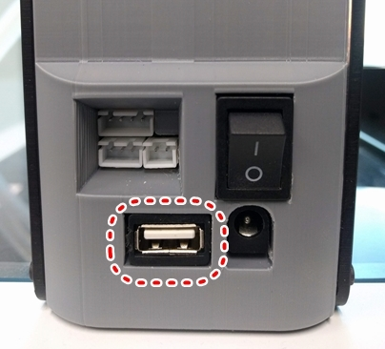 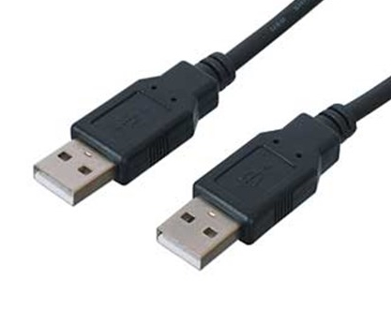

1. Copy the Uploader folder to any directory on your PC
2. Open Windows Command Prompt at your PC

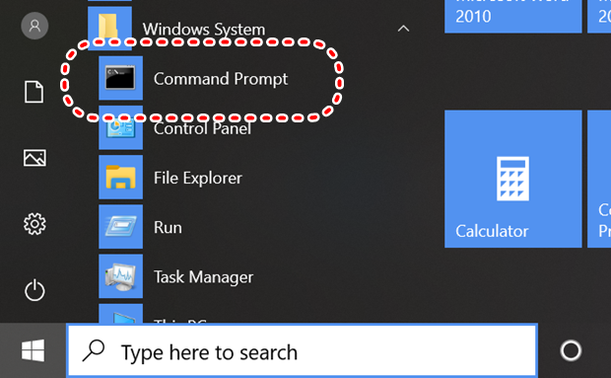

1. Change directory to uploader folder
2. Copy firmware.hex file to uploader folder

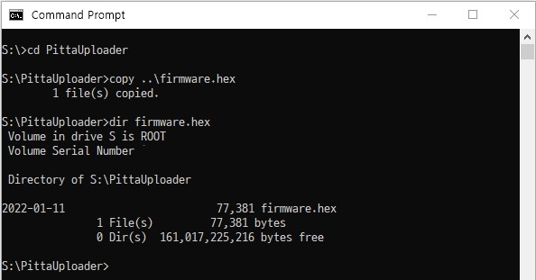

1. Run "uploader4pitta.bat firmware.hex" at Command Prompt

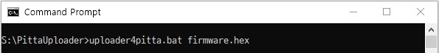

1. Upload progress displayed in the command prompt window
   * Detect Pitta's COM port detect
   * Reset Pitta MCU
   * Detect Bootloader's COM Port

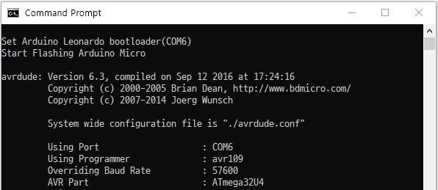

* + Upload firmware.hex file (Read -> Writing -> Verifying) to Pitta Base

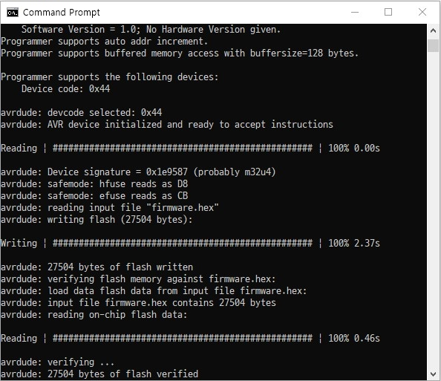

1. Confirm upload complete

